THIS - THESE - THAT - THOSE
En anglais, les démonstratifs -ce, ces- se classent en 2 catégories:
on distingue ce qui est près de ce qui est loin, tout comme en français avec ceci et cela.

1) 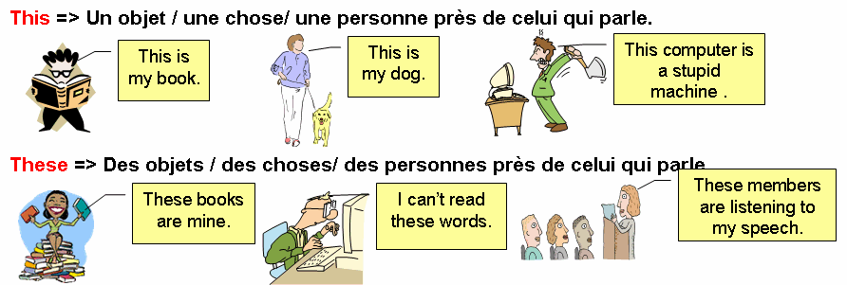
Application: Choisissez entre this et these.
------------- bicycles are yours. | these  this
Look! I really like ------------- dress. | this  these
Listen to -------------song, you'll like it. | these  this
What do you think of ----- ---pictures in your book? | this  these
------------ gift is for you, I think. | this  these
Watch ---------- earrings! I bought them this morning.
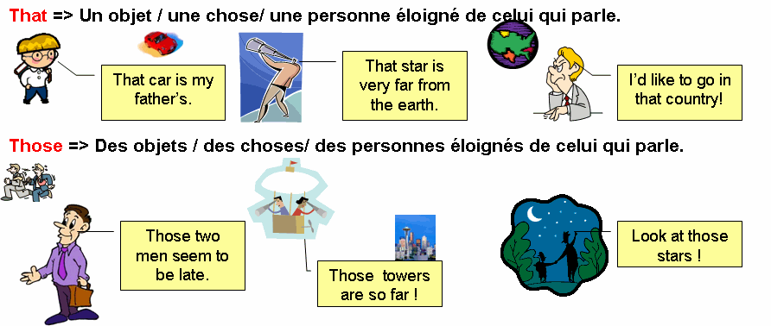
Application: Choisissez entre that et those.
----- clouds are forbidding. | those  that
----- is his car over there. | those  that
Could you bring me ----- book Peter gave you yesterday? | those  that
I would like some of ----- cakes on that shelf! | those  that
From my window I saw ----- two boys sitting on a bench.

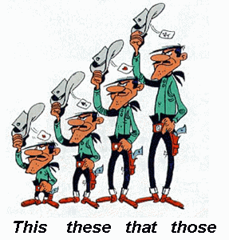

Choisissez maintenant entre ces 4 adjectifs démonstratifs.
I prefer ------------- hotel, it's cheaper than that one. | those  this  these  that
Do you want ----------- ones or those ones? | that  these  this  those
What are you doing with ------------ pencil in your hand? | that  those  these  this
Look at the sunset! ----------- is great! | those  that  these  this
What do you know about ------------ children who work in the world? | this  that  these  those
Could you repeat please? I didn't catch ------------ words. | these  those  that  this
Do you remember ----- French actress who played in 'Marie' in 1956? | these  that  this  those
It's too far; I have never been over there in ------------ country. | those  that  this  these
Put immediately your glass on ------------- table please. | these  this  those  that
I saw ----------- people running in the street and I shut my window.

This - That - These - Those
- "this" est utilisé pour un objet/une chose/une personne qui est près de l'énonciateur (celui qui parle) Exemple: This book is the best book on Earth. Ce livre est le meilleur livre du monde (l'énonciateur le tient dans sa main et il le montre).

- Pluriel : "these"Exemple: These books are the best books on Earth. Ces livres sont les meilleurs livres du monde.

> "that" est utilisé pour un objet/une chose/une personne qui est LOIN de l'énonciateur (celui qui parle) Exemple: That car over there is mine. Cette voiture, là-bas, est la mienne (il la pointe du doigt).
> Pluriel : those Exemple: Those cars over there are ours. Ces voitures, là-bas, sont les nôtres.
> "there" = "il y a..." S'accorde avec le nom qui suit et non avec "There". Exemple: There is (There's) a table next to the window.
> Plural: "there are" Exemple: There are many of my friends at the party tonight.

Mettez ces phrases au singulier ou au pluriel selon le cas. N'oubliez pas de mettre les ponctuations et n'oubliez pas de mettre au pluriel les déterminants, les noms, etc.

1. This is your book. => ______________________________
2. Those flowers are expensive. => ______________________________
3. That's my name. => ______________________________
4. This is Jack's shoe. => ______________________________
5. These pictures are Allison's. => ______________________________
6. I don't like those birds. => ______________________________
7. This apple is green, isn't it ? => ______________________________
8. Look at that yellow flower. => ______________________________
REPONSES:
1) These are your books.
2) That flower is expensive.
3) Those are our names.
4) These are Jack's shoes.
5) This picture is Allison's.
6) I don't like that bird.
7) These apples are green, aren't they ?
8) Look at those yellow flowers.

