The face
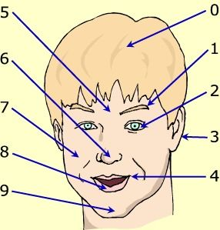
1. ==> the…………………………………( W Y R B O E E )
6. ==> the ………………………………… ( N S E O )
7. ==> the………………………………… ( E K E H C )
8. ==> the………………………………… ( I P L )
9. ==> the………………………………… ( N H C I )
10. ==> the………………………………… ( H R A I )
2. ==> the………………………………… ( E Y E )
3. ==> the………………………………… ( E R A )
4. ==> the………………………………… ( M O T U H )
5. ==> the………………………………… ( H R F D E O E A )

Vocabulary: the human body
Le corps  La main  La tête | 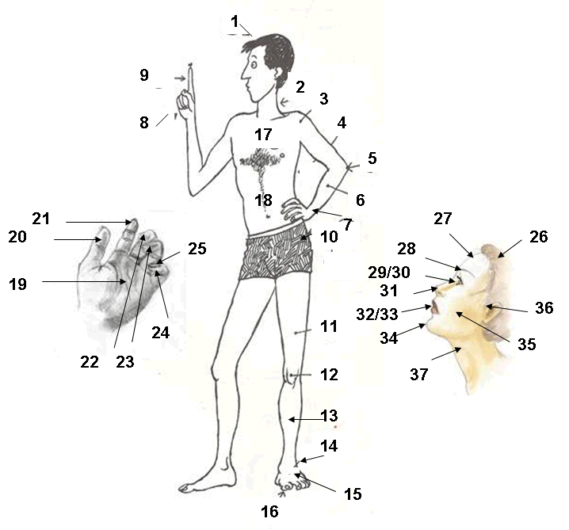
  1 | La tête | The head
  2 | Le cou | The neck
  3 | L'épaule | The shoulder
  4 | Le bras | The upper arm
  5 | Le coude | The elbow
  6 | L'avant bras | The forearm
  7 | Le poignet | The wrist
  8 | La main | The hand
  9 | Le doigt | The finger
  10 | La hanche | The hip
  11 | La cuisse | The thigh
  12 | Le genou | The knee
  13 | La jambe | The leg
  14 | La cheville | The ankle
  15 | Le pied | The foot
  16 | Les orteils | The toes
  17 | Le thorax | The chest
  18 | L'abdomen | The abdomen
  19 | La paume | The palm
  20 | Le pouce | The thumb
  21 | L'index | The index finger / forefinger
  22 | Le majeur | The middle finger
  23 | L'annulaire | The ring finger
  24 | L'auriculaire | The little finger
  25 | Un ongle | A nail
  26 | Les cheveux | The hair
  27 | Le front | The forehead
  28 | Les sourcils | The eyebrows
  29 | Les yeux | The eyes
  30 | Les cils | The eyelashes
  31 | Le nez | The nose
  32 | La bouche | The mouth
  33 | Les lèvres | The lips
  34 | Le menton | The chin
  35 | La joue | The cheek
  36 | L'oreille | The ear
  37 | La gorge | The throat

Questions:
Organ of smell which forms the beginning of the respiratory tract. = the _________________ ( S O E N )
The joint between the hand and the forearm. = the ____________________________ ( T S I W R )
The arch of short hairs on the ridge extending over the eye. = the ___________________ ( R O B W E E Y )
The first finger of your hand. = the ______________________________ ( H B T M U )
The articulation of the femur and the tibia covered anteriorly by the patella. = the __________ ( E E N K )
Under your mouth it is the lowermost part of the face.= the _____________________________ ( H C I N )
They grow on the back of the end of each finger and toe = the __________________________ ( I A L S N )
The part of the body enclosed between the ribs and the breastbone; the _________________ ( C H E T S )
The joint between the forearm and the upper arm. = the ______________________________ ( B L W E O )
Organ of hearing, responsible for maintaining equilibrium. = the _________________________ ( E A R )
Organ of smell which forms the beginning of the respiratory tract. = the ___________ ( S O E N N S E O )
The joint between the hand and the forearm. = the __________________________ ( T S I W R R S I T W )
The arch of short hairs over the eye. = the __________ ____________ ( R O B W E E Y E W B O E Y R )
The first finger of your hand. = the _____________________________________ ( H B T M U B T M H U )
The articulation of the femur and the tibia . = the ______________________________ ( E E N K N E K E )
Under your mouth it is the lowermost part of the face.= the _______________________ ( H C I N C I N H )
They grow on the back of the end of each finger and toe = the __________________ ( I A L S N S N L I A )
The part enclosed between the ribs and the breastbone; the ___________________( C H E T S E C S T H )
The joint between the forearm and the upper arm. = the ____________________ ( B L W E O W B E L O )
Organ of hearing, responsible for maintaining equilibrium. = the ___________________ ( E A R R E A )

