LES PRONOMS RELATIFS
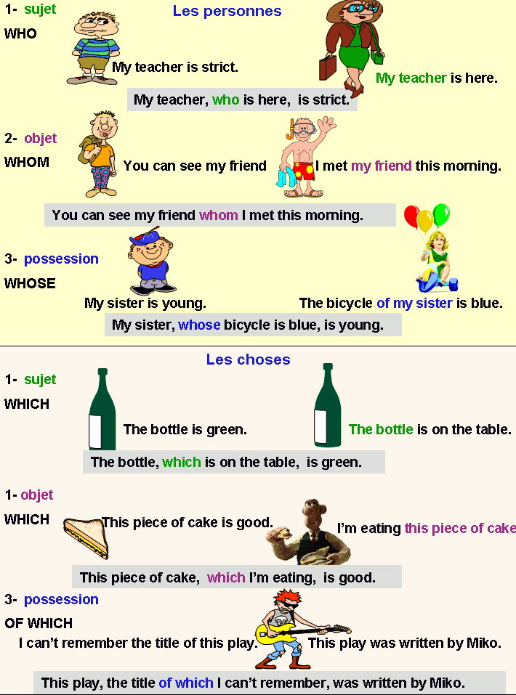

EXERCICE :
À partir des deux phrases proposées,complétez avec : who / whose / whom / which / of which.

Questions:
1. Peter is sick. / I met Peter yesterday.
Peter, _____________________________ I met yesterday, is sick.
2. These pupils are disruptive. / These pupils come into the classroom.
These pupils, _____________________________ come into the classroom, are disruptive.
3. My car is broken. / I crashed my car in a roundabout.
My car,_____________________________ I crashed in a roundabout, is broken.
4. That is my bus. / I usually take that bus.
That is the bus _____________________________ I usually take.
5. Here is a game. / I don't understand the rules of the game.
Here is a game the rules _____________________________ I don't understand .
6. John is fat. / The appetite of John is spectacular.
John, _____________________________ appetite is spectacular, is fat.
7. My book has been stained. / I put my book into the trash bag.
My book, _____________________________ I put into the trash bag,has been stained.
8. My father is coming back. / My father is in a bad mood.
My father , _____________________________ is coming back, is in a bad mood.
9. Maggy is crying. / I comfort Maggy.
I comfort Maggy _____________________________ is crying.
10. This child seems to be sad. / The school record book of this child is awful.
This child, _____________________________ school record book is awful, seems to be sad.

REPONSES:
1. whom
2. who
3. which
4. which
5. of which
6. whose
7. which
8. who
9. who
10. whose

