Le present perfect
En anglais, le 'present perfect' établit une relation entre un événement du passé et le moment où l'on parle. On s'intéresse donc aux résultats d'une action commencée dans le passé. ( marqueurs : already, not...yet, just, for, since, so far, recently, over the past few years...) …………………………………………………………………………………………………
Construction:
Have au présent (have, has ) + participe passé du verbe ( -verbe régulier: _ed ; verbe irrégulier: 3ème colonne ) :
Affirmation: Pierre has worked in a garage ( now he has money to spend ).
NEGATION: I have not done my homework. = I haven't done my homework. She has not done her homework. = She hasn't done her homework.
QUESTION: Have you done your homework? Yes, I have. / No, I haven't.

Conjuguer les verbes au present perfect - ATTENTION, les formes contractées ne sont pas acceptées:
1. Peter ______________________________ (steal) my trainers!
2. I ______________________________ (buy) this magazine.
3. We ______________________________ (write) three pages this afternoon.
4. ______________________________ (ever/you/be) to London?
5. I ______________________________ (not/finish) my homework yet.
6. My dog ______________________________ (eat) all my cookies!
Use the contractions in the negative form.
1. I ______________________________ a new car. (to buy / just)
2. They ______________________________ yet where to go on holiday. (not to decide)
3. Alain ______________________________ to the cinema. (to go)
4. I ______________________________ 'the good, the bad and the ugly ' : I like it (to see )
5. ______________________________ to England ? (to be / you / ever)
6. Julien ______________________________ his friend. (to meet / just)
7. Recently, we ______________________________ many parties with our friends. (to have)
8. What ______________________________ during the holidays? (to do / you)
9. He ______________________________ (not to work)
10. ______________________________ (finish / already / you) ?
Compléter les phrases pour obtenir les verbes au present perfect.
1. I have ______________________________(be) in London.
2. I have ______________________________(find) that stone on the beach.
3. He has ______________________________(see) her in this house for the last time.
4. Who has ______________________________(eat) a cake ?
5. I have ______________________________(lose) my keys among the crowd.
6. This car has ______________________________(crash into) that one.
7. We have ______________________________(burn) this chair.
8. They have ______________________________(do) it !
Prétérit ou present perfect - Les différencier par l' image
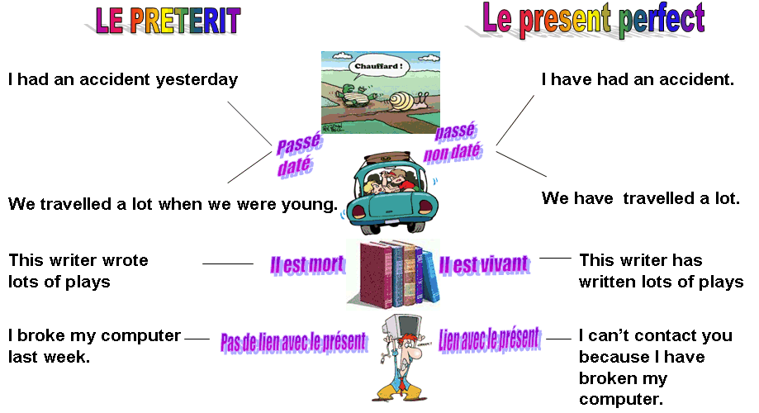
Mettez les verbes entre parenthèses au present perfect ou au prétérit.(Pas de formes contractées).
1. (to play) => He ______________________________ a lot of rugby when he was young.
2. (to write) => I ______________________________ a letter to Laurent so he knows everything.
3. (to write) => Napoleon ______________________________ the French Civil Code.
4. (to have) => He ______________________________ an accident near the village
5. (to drink) => Vincent ______________________________ too much last night.
6. (to arrest) => The police ______________________________ a well-known robber
7. (to read) => He ______________________________ that book twice
8. (to visit) => Last month we ______________________________ his new house.
9. (to decide) => They ______________________________ to go on strike
10. (to decide) => You'll have to pay more taxes as the government ___________ to add a tax on cola
1. He was there yesterday and he ______________________________(talk) to me.
2. Something incredible ______________________________ (just/happen) to me !
3. I ______________________________ (forget) to call my boyfriend last week.
4. I ______________________________ (buy) a new red car yesterday!
5. When ______________________________ (you / tell) your parents about it ?
6. I love England so I ______________________________ (leave) France to live over there.
7. I ______________________________ (decide) to get involved in Greenpeace.
8. I ______________________________ (go) to Paris yesterday morning.
9. I ______________________________ (go /not) to Windsor last year.
10. ______________________________(she /leave) a message yesterday?
11. ______________________________(he /tell /never) us about it.
12. They ______________________________ (give) us the key to his flat.
13. He ______________________________(just/ win) the second prize.
14. If only I ______________________________ (know) what she really thinks !
15. I wonder why Lily ______________________________(not/speak) to me last Monday.
16. Last year Mrs Holding ______________________________(stare) ahead of her to where the spaceship was waiting.

Pour chaque phrase affirmative conjuguée au present perfect, trouvez la forme interrogative correcte parmi les 3 qui vous sont proposées.

1) I have eaten an apple. __________________
2) You have bought some bread. __________________
3) He has travelled a lot. __________________
4) We have been to London. __________________
5) They have lost their dog. __________________
6) She has visited Big Ben. __________________
7) It has been a lovely day. __________________
8) We have taken your umbrella. __________________
9) I have sent a letter. __________________
10) It has been easy ! __________________

Bilan sur le passé
L'erreur la plus fréquente est de comparer le temps du verbe français au temps du verbe anglais.
Exemples :
Le verbe français est au présent, j'emploie donc un présent anglais.
Le verbe français est au passé composé, j'emploie donc le present perfect.
Avec cette méthode vous courez à la catastrophe ! Il ne faut pas faire ainsi.


Les bonnes questions à se poser sont : quand et comment l'action se déroule t-elle ? quelles sont ses conséquences sur le présent?
Par exemple, pour un seul temps EN FRANCAIS, on peut avoir 3 temps EN ANGLAIS: présent simple, présent en BE + ING, present perfect.
C'est pour cela qu'il ne faut pas associer dans sa tête un temps français à un temps anglais.
Action habituelle, répétitive: présent simple
I drink tea at 5 pm everyday.
Je bois du thé tous les jours à 5h de l'après-midi.
Action en progression au moment où l'on parle: présent en BE + ING
I am drinking tea right now. (Je bois du thé en ce moment.)

Action passée, terminée: prétérit simple
J'ai bu du thé hier....quand ? ...hier...c'est daté donc on emploiera le prétérit.

I drank tea yesterday.

L’action a lieu dans le passé toujours mais…
On constate un lien entre le passé et le présent, on fait un bilan, on s'intéresse au résultat présent d'une action passée, on s'intéresse à ses conséquences sur le présent :
On emploiera le present perfect
Exemples :
A building has collapsed today in Glasgow.(Un immeuble s’est effondré aujourd’hui à Glasgow / Un immeuble s’effondre…)
Cela fait penser à un gros titre dans un journal ? oui c’est le cas.
Les articles de journaux sont le plus souvent écrits au present perfect.

I am afraid she has gone out. (Je crains qu’elle ne soit sortie / qu’elle ne soit pas là…)
Conséquence : vous ne pouvez pas la voir.
Le fait qu’elle soit sortie a un lien avec le présent = cela vous empêche de la voir.

She can’t go to London because her flight has been cancelled (Elle ne peut pas aller à Londres car son vol a été annulé)
Conséquence / bilan : elle ne va pas y aller à la nage !
La conséquence est qu’elle restera encore quelques jours chez moi !

She has lived here for five years. (Elle vit ici depuis cinq ans)
Bilan : cela fait cinq ans qu’elle vit ici.
Noter que l’on peut employer la forme progressive pour insister sur la durée de l’action
She has been living here for five years

On emploie le present perfect avec certains adverbes.
Have you ever met Mary ?
She has already been to Chicago .
He has not finished his homework yet.
Everything has been all right so far.
He has never written to her.

Exercice : Choisir le verbe juste parmi ceux qui sont proposés.


Questions:
1) Tom Cruise __________________ in a lot of recent films. He's a big star!
acted
acts
has acted
2) Sorry, you can't speak to Jane, she __________________.
will go out
has gone out
went out
3) When she was young she __________________ handball. She is 95 now.
played
plays
has played
4) Do you know that the Jones __________________ their party ? There is no need to hurry.
have called
have called off
called off
5) This boy works hard but he __________________ his homework yet.
have not finished
did not finish
has not finished
6) My parents __________________ forty years ago.
have got married
will get married
got married
7) 'A wolf __________________ sheep near a village in the French Alps' reports a French newspaper.
have killing
has killed
killed
8) The house they __________________ is too small for them and their four children. They need a bigger one.
have bought
buys
bought
9) Tolstoï __________________ 'Anna Karenina' , his most famous novel, in 1877.
is writing
wrote
has written
10) She __________________ that film a lot of times. She loves it!
has seen
have seen
saw
11) John F. Kennedy __________________ the 35th president of the USA.
has been
will be
was
12) Where is my secretary, John?...I am afraid she __________________ a day off Sir.
takes
took
has taken
13) Do you enjoy your meal Tom? ..oh yes it __________________ marvellous so far.
has been
will be
is
14) I read this book yesterday, __________________ it?
have you ever read
have you never read
did you ever read

REPONSES:
1. has acted
2. has gone out
3. played
4. have called off
5. has not finished
6. got married
7. has killed
8. have bought
9. wrote
10. has seen
11. was
12. has taken
13. has been
14. have you ever read

EXPLICATIONS:
1) Tom Cruise est vivant,c'est un bilan; on fait un bilan de sa carrière cinématographique.
2) Non daté et la conséquence est que vous ne pouvez pas voir Jane.
3) Daté puisqu'on précise l'époque (quand elle était jeune)
4) Non daté et c'est un bilan,un constat.
5) Le mot "yet" implique l'emploi du present perfect.
6) Daté car on dit 'il y a 40 ans'.
7) Article de journal au present perfect. On fait le constat de cet incident.
8) Non daté et c'est un bilan,un constat avec conséquence,ils vont devoir acheter une maison plus grande.
9) Tolstoï est mort, donc l'action est terminée et ne pourra plus se reproduire.
10) Non daté, mais là on peut reproduire l'action.
11) JFK est mort donc prétérit obligatoire. Il s'agit de la simple énonciation d'un fait.
12) Non daté et c'est un constat avec conséquence = le patron n'a plus qu'à écrire ses lettres lui-même.
13) So far demande l'emploi du present perfect.
14) Ever demande l'emploi du present perfect.

Passé simple ou present perfect?
Mettre les verbes au passé simple ou au present perfect simple (attention le present perfect en -ING n'est pas validé dans cet exercice).

Questions:
1. I'm afraid, Patricia ______________________________ (leave) the office an hour ago.
2. I'm afraid , Patricia isn't here. She ______________________________ (leave) the office.
3. Today, she ______________________________ (be) really busy and it's only 2:00 P.M . She still has a lot of things to do.
4. Yesterday, I ______________________________ (be) very busy. I left my work at 8 pm.
5. We ______________________________ (go) to an interesting Seminar last month.
6. I...______________________________...(work) here since the end of last year.
7. I ______________________________ (see) David a few days ago.

REPONSES:
1) left
2) has left
3) has been
4) was
5) went
6) have worked
7) saw

Present perfect ou preterit ?

Questions:
1. My uncle ______________________________ (go) on a trip to Egypt three years ago.
2. Roy ______________________________ (finish-just) repairing the washing-machine,you can use it now.
3. His worst memory: when he ______________________________ (have) to swim in the North Seas.
4. When I was a child I ______________________________ (believe) in ghosts.
5. Last year, we ______________________________ (visit) the British Museum.
6. What is the most frightening experience ______________________________ (you-have-ever) ?
7. Many students in my class ______________________________ (travel-already) abroad.
8. I ______________________________ (steal-never) anything in my life.

REPONSES:
1) went
2) has just finished
3) had
4) believed
5) visited
6) you have ever had
7) have already travelled
8) have never stolen

Present Perfect or Past Simple
Complétez avec le verbe conjugué soit au present perfect, soit au prétérit.

Questions:
1. Where's your key? I don't know. I (lose) ______________________________ it.
2. I (be) ______________________________ very tired, so I lay down on the bed and went to sleep.
3. Mary (go) ______________________________ to Australia for a while but she's back again now.
4. 'Where's Ken?'. He (go) ______________________________ out. He'll be back in about an hour.
5. I did German at school but I (forget) ______________________________ most of it.
6. I meant to phone Diane last night but I (forget) ______________________________ .
7. I (have) ______________________________ a headache earlier but I feel fine now.
8. Look! There's an ambulance over there. There(be) ______________________________ an accident.
9. They're still building the new road. They (not/finish) ______________________________ it.
10. 'Is Helen still here'? No, she (just/go) ______________________________ out.
11. The police (arrest) ______________________________ three people but later they let them go.
12. Ann (give) ______________________________ me her address but I'm afraid I've lost it.
13. Where's my bike? It was outside the house. It (disappear) ______________________________
14. What do you think of my English? Do you think I (improve) ______________________________ it ?

REPONSES:
1) have lost
2) was
3) went
4) has gone
5) have forgotten
6) forgot
7) had
8) has been
9) haven't finished
10) has just gone
11) arrested
12) gave
13) has disappeared
14) have improved

