Prépositions de lieux (grand cours)
LES PREPOSITIONS DE LIEUX...
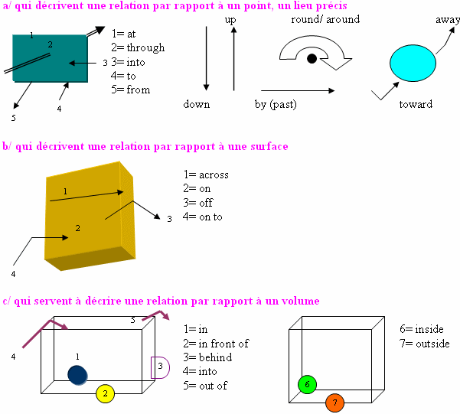
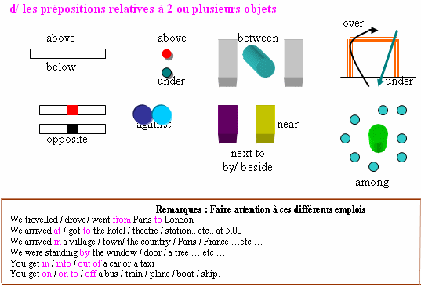

EXERCICE: Regardez attentivement ces situations et complétez les phrases avec les bonnes prépositions.

Questions:
1. The cat is _____________________________ the vase.
2. The little girl is looking _____________________________ the window at something
3. The plane is flying _____________________________ the buildings.
4. The coins are _____________________________ the table.
5. The plant is _____________________________ of the window.
6. The red book is _____________________________ the green book and the brown book.
7. Mrs Carlson is _____________________________ her husband.
8. Marc is walking _____________________________ the road.
9. The planes are _____________________________ the airport.
10. The children are _____________________________ the US flag..
11. The red cube is _____________________________ the blue cube.
12. The drawers are _____________________________ the desk.
13. The boat is _____________________________ the pond.
14. Lucy is walking _____________________________ the school.
15. John is _____________________________ the other pupils.
16. Some cereals are _____________________________ the box. What a pity!
17. The frog is going _____________________________
18. The frog is going _____________________________
19. Mrs Parker is going _____________________________ the taxi.
20. Paul and Mary are walking _____________________________
21. The thief entered _____________________________ the back door.

REPONSES:
1. in
2. out of
3. over
4. on
5. in front of
6. between
7. next to
8. across
9. around
10. opposite
11. above
12. under
13. on
14. toward(s)
15. among
16. outside
17. down
18. up
19. into
20. away
21. by

la décoration de l'appartement de Thierry.
'The room is L-shaped. There's a round dining table and four chairs opposite the
kitchen door - I can look out into the garden when I have dinner.
My record-player is in the corner, between the kitchen door and the small window.
There are bookcases on both sides of the fireplace, and a rectangular coffee table
in front of the fire. My bed is against the long wall, under the large window. I use it as a
sofa during the day, so there are some big, striped cushions on it.
Opposite the bed, against the kitchen wall, there's a desk, and between the bed and the
desk there's a large armchair. I like sitting and reading in front of the fire with my feet
up on the coffee table . In the empty space in front of the door, there's an oval carpet
on the floor. And the piano is in the corner between the door and my bed.'

1° Traduisez chaque mot souligné, dans l’interligne du texte 2° Replacez chaque élément sur le plan de l'appartement en complétant la liste ci-jointe (temps maximal: 30 minutes): Chaque objet peut être placé à un seul endroit. Attention, pour compliquer l'affaire, il restera à la fin des emplacements vides que vous désignerez comme 'intrus'.
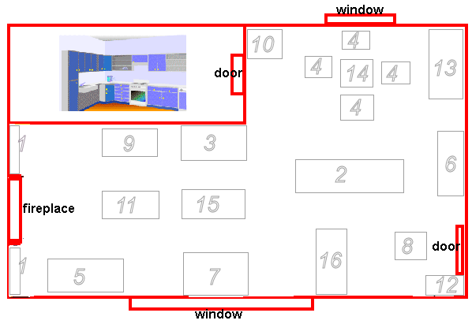

Complétez par le nom de l’objet,en Anglais,puis en Français, correspondant au numéro sur le plan (Les fautes d’orthographe coûtent un point chacune……….)
1. _____________________________
2. _____________________________
3. _____________________________
4. _____________________________
5. _____________________________
6. _____________________________
7. _____________________________
8. _____________________________
9. _____________________________
10. _____________________________
11. _____________________________
12. _____________________________
13. _____________________________
14. _____________________________
15. _____________________________
16. _____________________________

REPONSES:
1. bibliothèque
2. intrus
3. bureau
4. chaise
5. intrus
6. intrus
7. lit
8. tapis
9. intrus
10. mange-disques
11. petite table basse
12. piano
13. intrus
14. table ronde
15. fauteuil
16. intrus

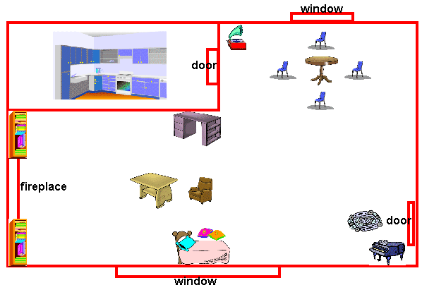
Tous les objets sont correctement placés? Bravo!

