Présent en BE + -INGConjugaison de l'auxiliaire to BE (être)
L'objectif du jour: > Savoir dire: "(en ce moment), je joue au football".
Pronom | auxiliaire | traduction
I | am | je suis
you | are | tu es
he | is | il est
she | is | elle est
it | is | il/elle est
we | are | nous sommes
you | are | vous êtes
they | are | ils sont
 La solution: > Il faut utiliser le présent en BE + -ING, qu'on appelait auparavant présent progressif/présent continu. Ce temps se forme avec l'auxiliaire BE, suivi du verbe en -ing (on prend le verbe et on rajoute -ing à la fin).
Exemple avec le verbe "play" (jouer)
On remarque que le verbe "playing" est identique à toutes les formes. Ce qui permet d'indiquer la 1ère, 2e, 3e personne du singulier/pluriel, c'est la conjugaison de l'auxiliaire BE.
Pronom | auxiliaire | verbe | traduction
I | am | playing | je suis en train de jouer / je joue
you | are | playing | tu es en train de jouer / tu joues
he | is | playing | il est en train de jouer / il joue
she | is | playing | elle est en train de jouer / elle joue
it | is | playing | il/elle est en train de jouer / il-elle joue
we | are | playing | nous sommes en train de jouer / nous jouons
you | are | playing | vous êtes en train de jouer / vous jouez
they | are | playing | ils sont en train de jouer / ils jouent

Exercice: Compléter ces phrases avec le verbe entre parenthèses conjugué au présent en BE + -ING: ATTENTION, LES FORMES CONTRACTEES NE SONT PAS ACCEPTEES DANS CET EXERCICE.
1. I ______________________________ (sing). Je chante.
2. You ______________________________ (play) football. Tu joues au football.
3. She ______________________________ (take) her umbrella. Elle prend son parapluie.
4. She ______________________________ (sit) on the chair. Elle est assise sur une chaise.
5. They ______________________________ (eat). Ils mangent.
6. We ______________________________ (go) to the cinema. Nous allons au cinéma.
Voici un petit test très simple concernant le présent en BE + -ing. Il s'agit de conjuguer correctement le verbe placé entre parenthèses, en le mettant à la forme en -ing. N'oubliez pas l'auxiliaire BE. Bonne chance1. I ______________________________ (play) base-ball.
2. She ______________________________ (look) for her book.
3. You ______________________________ (go) to the station.
4. They ______________________________ (speak) with the policeman.
5. He ______________________________ (say) he doesn't need a coach.
6. I ______________________________ (think) about her.
7. They ______________________________ (look) at the clown.
8. I ______________________________ (watch) TV.
9. You ______________________________ (play) with your computer.
10. We ______________________________ (try) to stop this.
Comment poser des questions ? Il faut déterminer quel verbe va être employé.
Nous avons 3 sortes de verbes:
1- les auxiliaires : to be, to have
2- les modaux :can, may, must...
3- les verbes ordinaires: ce sont tous les autres verbes, divisés en verbes réguliers et en verbes irréguliers.
Si la question contient un auxiliaire on fera l'inversion verbe/sujet.
Les auxiliaires peuvent être BE, HAVE mais aussi will, shall, should, would. Exemples:
He is French is he French?
She will go to school will she go to school?
He would work harder... would he work harder?
Les modaux se conjuguent comme les auxiliaires donc avec l'inversion verbe/sujet.
Exemples:
He can swim... can he swim?
She may go out tonight.. . may she go out tonight?<>
They must work hard... must they work hard?
Les verbes ordinaires, réguliers ou irréguliers, ont besoin d'un auxiliaire qui sera alors 'do'.
C'est l'auxiliaire qui est conjugué, pas le verbe lui-même qui reste à l'infinitif sans to.C'est pourquoi on aura 'does' à la 3éme personne du singulier du présent, et 'did' au prétérit.
Exemples:
She likes chocolate... does she like chocolate?
They go to school... do they go to school?
She brushed her hair... did she brush her hair?
We went out... did we go out?
He took the bus... did he take the bus?

Attention à un point important: Avant d'employer do/does/did cherchez le sujet du verbe car do/does/did ne s'emploient pasdans les questions dont le sujet est un pronom interrogatif tel que who, what ou which. Exemples:
What do you think of that?...le sujet est 'you' donc on emploie 'do'.
Which book does she read?...le sujet est 'she' donc on emploie 'do'.
What happens here?...le sujet est 'what' donc on n'emploie pas 'do'.
Who wrote that novel?...le sujet est 'who' donc on n'emploie pas 'do'.



Exercice : Trouver la bonne question parmi celles proposées.
Questions:
1) She likes going to the restaurant.__________________
Where likes she going?
Where does she like going?
Where do she like going?
Where like she going?
2) He is a handsome and clever man.__________________
Do he be a handsome man?
Is he a handsome man?
Is he be a handsome man?
Does he is a handsome man?
3) She speaks English fluently.__________________
Does she speak English fluently?
Speak she English fluently?
Speaks she English fluently?
Is she speak English fluently?
4) He worked all night.__________________
Did he work all night?
Worked he all night?
Did he be work all night?
Did he worked all night?
5) She bought a marvellous dress.__________________
What bought she?
What she bought?
What did she bought?
What did she buy?
6) They talked to Jim yesterday.__________________
Who did they talked to?
Who do they talked to?
Who talked they?
Who did they talk to?
7) They must do their homework.__________________
What is they must do?
What do they must do?
What must they do?
What they must do?
8) She ate a big hamburger.__________________
What eat she did?
What ate she?
What did she eat?
What do she ate?
9) He will go to England.__________________
Where do will go he?
Where go will he?
Where he will be go?
Where will he go?
Négation au présent
Ecrivez les phrases suivantes à la forme négative. Utilisez la forme contractée des verbes.

1. Joshua is from Canada ______________________________
2. Joshua comes from New Jersey. ______________________________
3. His parents work on television. ______________________________
4. He likes his new school. ______________________________
5. He is in year 10 with Kate and Bryan. ______________________________
6. Kate has got a step-mother. ______________________________
7. Bryan's half-sisters fight. ______________________________
8. Joshua's parents work in Plymouth. ______________________________
9. Joshua has a lot of friends in London. ______________________________
10. His new schoolfriends are Janet and Jason. ______________________________

Mettre à la forme interrogative (i) ou à la forme négative (n).

1. Peter always finishes work at 6 o'clock.(i)______________________________
2. She knows those girls (n)______________________________
3. I buy a new record every week. (n)______________________________
4. John usually does his work well. (i)______________________________
5. They carry their books to school every day. (i)______________________________
6. Mary wants to wear her new dress. (n)______________________________
7. Mr Johnson washes his car every Saturday. (i)______________________________
8. Jane always listens to the radio in the evening. (i)______________________________
9. Carol is in the garden. (n)______________________________
10. You like English. (i)______________________________
Phrases 1 à 5: mettre la phrase à la forme interrogative.
Phrases 6 à 10: mettre la phrase à la forme négative.
Mettre les formes contractéesQuestions:
1. Bob and his wife live in New Zealand. ______________________________
2. Pat's watching TV in the kitchen.______________________________
3. Molière lived in the seventeenth century.______________________________
4. They'll find a hotel in London.______________________________
5. He can't buy his children new clothes. ______________________________
6. Peter understands everything. ______________________________
7. Dinosaurs ate men. ______________________________
8. Are you at home on Fridays? ______________________________
9. Children must play all the time. ______________________________
10. I'd like to live in Canada. ______________________________

Mettre les phrases suivantes à la forme négative.
1) Matt is late for school.__________________
Matt does not is late for school.
Matt does not late for school.
Matt is not late for school.
2) Peter and Brian play tennis every week.__________________
Peter and Brian play not tennis every week.
Peter and Brian does not play tennis every week.
Peter and Brian do not play tennis every week.
3) The trees in this park are very old.__________________
The trees in this park do not are very old.
The trees in this park aren't very old.
The trees in this park are very not old.
4) This test is very easy.__________________
This test isn't very easy.
This test does not is easy.
This test does not easy.
5) My mother likes to paint.__________________
My mother don't like to paint.
My mother is not like to paint.
My mother does not like to paint.
6) They were impressed by his performance.__________________
They did not impressed by his performance.
They didn't were impressed by his performance.
They were not impressed by his performance.
7) My brother is older than my sister.__________________
My brother is doesn't older than my sister.
My brother doesn't is older than my sister.
My brother isn't older than my sister.
8) Robert and you are my best friends. __________________
Robert and you aren't my best friends.
Robert and you isn't my best friends.
Robert and you is not my best friends.
9) This show was excellent.__________________
This show didn't was excellent.
This show was not excellent.
This show weren't excellent.
10) You rang the bell twice.__________________
You didn't rang the bell twice.
You did not ring the bell twice.
You don't rang the bell twice.

Les deux principaux présents en anglais
(en plus du present perfect, qu'on verra plus tard)
Le présent simple s'emploie pour parler de ce qui n'est pas limité au contexte actuel: donc
-des faits plus ou moins permanents
-des actions qui se répètent
- des habitudes.
Le présent en BE+ING (anciennement appelé présent progressif/présent continu - ces deux appellations n'existent plus) s'emploie
- dans un contexte temporaire / transitoire et en cours
(que ce soit une situation de durée limitée, une action ou une brève série d'actions).

Un exemple pour cerner la différence entre les deux présents:
Water boils at 100°C => l'eau bout à 100°C (C'est un fait permanent).
Maintenant imaginez que vous êtes dans votre cuisine en train de préparer du thé, l'eau se met à bouillir, tant mieux, c'est ce que vous attendiez, mais vous la retirez du feu pour préparer votre boisson. Ce n'est donc plus un fait permanent mais temporaire. Vous direz:
The water is boiling I'll make my tea. => L'eau bout, je vais faire mon thé.
Voici un tableau récapitulatif pour vous aider
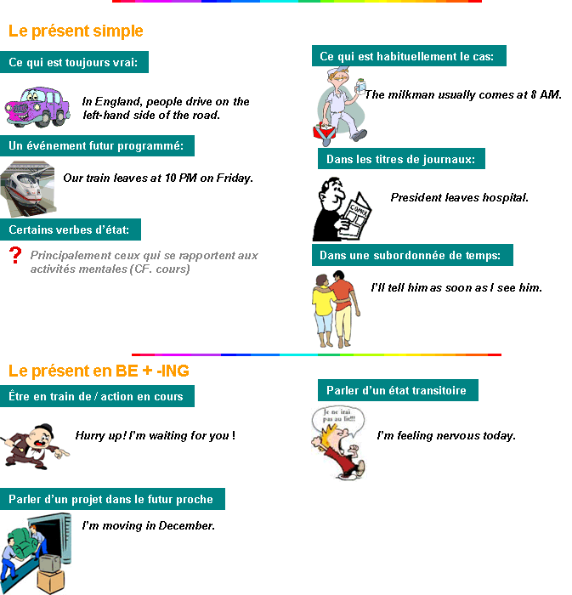
Le présent et les verbes d'état
Certains verbes n'ont jamais ou presque jamais de forme progressive.
Ils se mettent au présent simple même lorsqu'ils se rapportent au moment présent.
Ce sont principalement les verbes qui font référence à un état mental, émotionnel.
Voici quelques exemples:
believe (croire), doubt (douter), know (savoir, connaître), understand (comprendre),
mean (signifier), recognize (admettre), remember (se souvenir), suppose (supposer)
like, love (aimer), need (avoir besoin), prefer (préférer), want (vouloir), wish (souhaiter), seem (sembler).
Certains verbes s'emploient avec ou sans forme progressive selon le sens.
►Be s'emploie à la forme progressive pour parler du comportement actuel de quelqu'un et lorsqu'il est auxiliaire au passif.
Dave's being ridiculous! =>Dave se comporte de façon ridicule!
I'm being watched => On me regarde.
Dans les autres cas -be- n'a pas de forme progressive.

►Feel peut s'employer à la forme progressive au sens de - (se) sentir
Now Lucile feels fine (ou ... is feeling fine) => Maintenant Lucile se sent bien.
- mais pas au sens de - croire -.
Sylvie feels Lucile's right => Sylvie croit que Lucile a raison.

►Have s'emploie à la forme progressive pour parler des activités
We're having a fantastic journey => Nous faisons un voyage fantastique.
mais pas pour parler de la possession, des relations ..etc...
We have no friends => Nous n'avons pas d'amis.

►See s'emploie à la forme progressive au sens de - rencontrer - parler avec
I'm seeing Julien tomorrow => Je vois (rencontre) Julien demain.
mais pas dans les autres sens.
I see what Julien means. => Je vois ce que Julien veut dire.
►Think ne s'emploie pas à la forme progressive lorsqu'on parle d'une opinion.
Laurent thinks Brigitte is wrong => Laurent pense que Brigitte a tort.
What are you doing? - I'm thinking. => Que fais-tu? - Je suis en train de réfléchir.


Mettez les verbes au présent simple ou le présent en BE+-ING (aucune contraction)

Questions:
'My name ______________________________ (to be) Peter;
l ______________________________ (to live) in the suburbs of Boston with my family.
Most people ______________________________ (to believe)
we ______________________________ (to be) rich because
we ______________________________ (to live) in a big house.
But our family ______________________________ (to seem) to be like any other one. Have a look:
Maggy, my wife, ______________________________ (to like) cooking.
She ______________________________ (to enjoy) being in the kitchen with her friends.
At the moment she ______________________________ (to make) a cake and you can't talk to her.
What really ______________________________ (to worry) her is our daughter
who ______________________________ (to prefer) to chat in front of her computer instead of cooking with her.
Like many teenagers, Jenny ______________________________ (to think)
it ______________________________ (to be) easier to get advice from someone
you ______________________________ (not + to go to) see later.
It's 5 pm. Paul, my son, ______________________________ (to play) basketball in the garden
and I ______________________________ (to watch) TV,
I ______________________________ (to wait) for this delicious cake
that Maggy ______________________________ (to cook) . I told you, a family as yours. '
Peter

REPONSES:
1) is
2) live
3) believe
4) are
5) live
6) seems
7) likes
8) enjoys
9) is making
10) worries
11) prefers
12) thinks
13) is
14) are not going to
15) is playing
16) am watching
17) am waiting
18) is cooking

